|  |  |
| --- | --- |
|  |  |
|  |  |

Note: Reference images used for flavour only, not actual gameplay footage

**Project “Dragon”**

**Game Design Document**

**Document created by Rick Davidson**

**Game Overview**

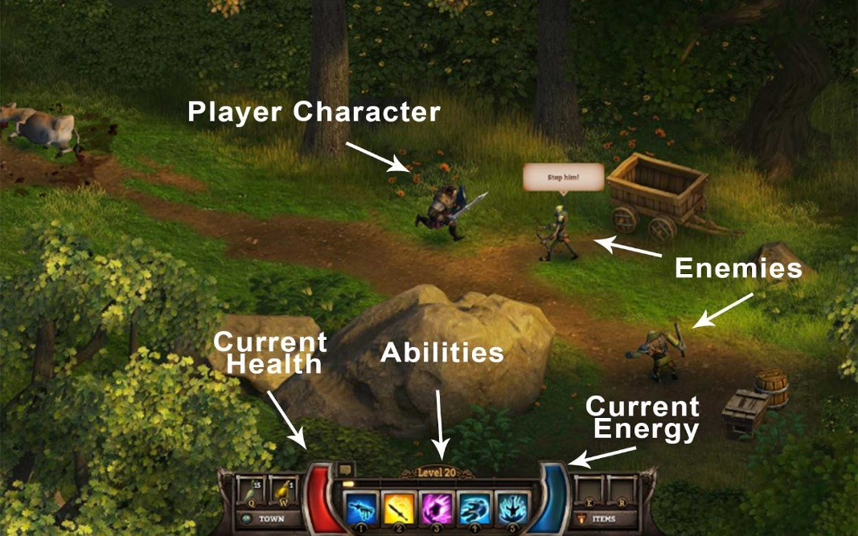

**Game Summary**

“Diablo meets Monty Python”

Project Dragon is a Diablo style fixed-camera Action-RPG with the absurd humour of Monty Python and the Holy Grail. The game is set during the grubby phase of the medieval era when the nobility flaunted their status and unbathed peasants reeked of toil. You play an unlikely hero - an 86 year old cabbage farmer who is determined to finally make his mark on the world by persisting despite the odds and, you know, maybe overthrowing the monarchy or something like that.

The game is being created hand-in-hand with the “how to build an RPG” online course and will feature community created content as a sexy highlight.

**What is the Game Genre?**

* Single player, Fixed-camera, 3rd-person Action RPG (like old school Diablo games).

**What is the Player Experience?**

* **Funny, Absurd, Comedic.**
* Our goal is to make the player: laugh and say “what they hell did I just watch”.
* The game will not take itself seriously, instead poking fun at itself, the player and the entire RPG genre where possible.
* The humour and absurdity will be applied to situations, actions, events and what the characters.
* Our main point of “weirdness” will be activities / situations rather than character types or world setting. That is, regular hero up to crazy things in a fantasy world.

Reference: Monty Python and The Holy Grail.

**What is the Game’s Theme?**

“Failure Can’t Tolerate Persistence”. Through our story and game elements we will reinforce that the hero is underpowered, but resolute.

**Who is the Target Audience?**

* 13 yrs+ fans of old school RPGs like Diablo. People who like comedy.
* The target PEGI rating is: PEGI 12
* The target ESRB rating is: T for Teen
* With a Teen / PEGI 12 target audience we will be limited to mild language, not too much gore and hidden meaning in things that only the mighty minds of 13 year olds and above will understand.

**What is the Setting?**

* Medieval Europe. Fantasy setting.
* Knights, wizards, monsters, swords, dragons, peasants, cabbages.
* The world that the peasants live in is harsh, grubby and unforgiving. Things are generally run down and very “lived in”.

|  |  |
| --- | --- |
| Image result for RPG in game |  |
|  | https://lh3.googleusercontent.com/xcBrR637gC1d3I1hKsjlALaLkoxtutk8dEObZ1srTJHmwsD7FvJ1ynrPMiOXgf6VFGjoN8zx4tSYBwyvaAKrgiRCguVTfzFIXNayikQ9M800EXWWgJXc-zJGVrvZAbZ9IWWU6j7d |
|  |  |

Reference images which speak to the game’s setting

**What are the technical details?**

* Developed using: Unity with C#.
* Art Assets: 3D game world and characters with 2D User Interface.
* Platform(s): Steam.
* Controls: Mouse / Keyboard and also Game Controller.

**[BRAINSTORM] Game title ideas**

A place to brainstorm game titles as the project progresses…

* Mopey Dragon & The Holey Veil
* Why Are Dragons Jerks?
* All Dragons are Jerks.
* The Reluctantly Unlikely Hero
* All Dragons Lie
* Clumsy Dragon and the Holey Veil
* Ministry of Intriguing Peasants (M.O.I.P)
* My Dirty Old Hoe
* Rutabaga Baby: The Quest for the Golden Turnip

Note: I think we need to make our game title unusual in structure as this would fit with our overall Player Experience of funny and absurd - a sensible name would break the consistency. Not as rickdiculous as the game “AaaaaAAaaaAAAaaAAAAaAAAAA!!! for the Awesome”

**When will it launch?**

Our target for Steam Early Access is Q4 2017.

**Camera, Character and Controls**

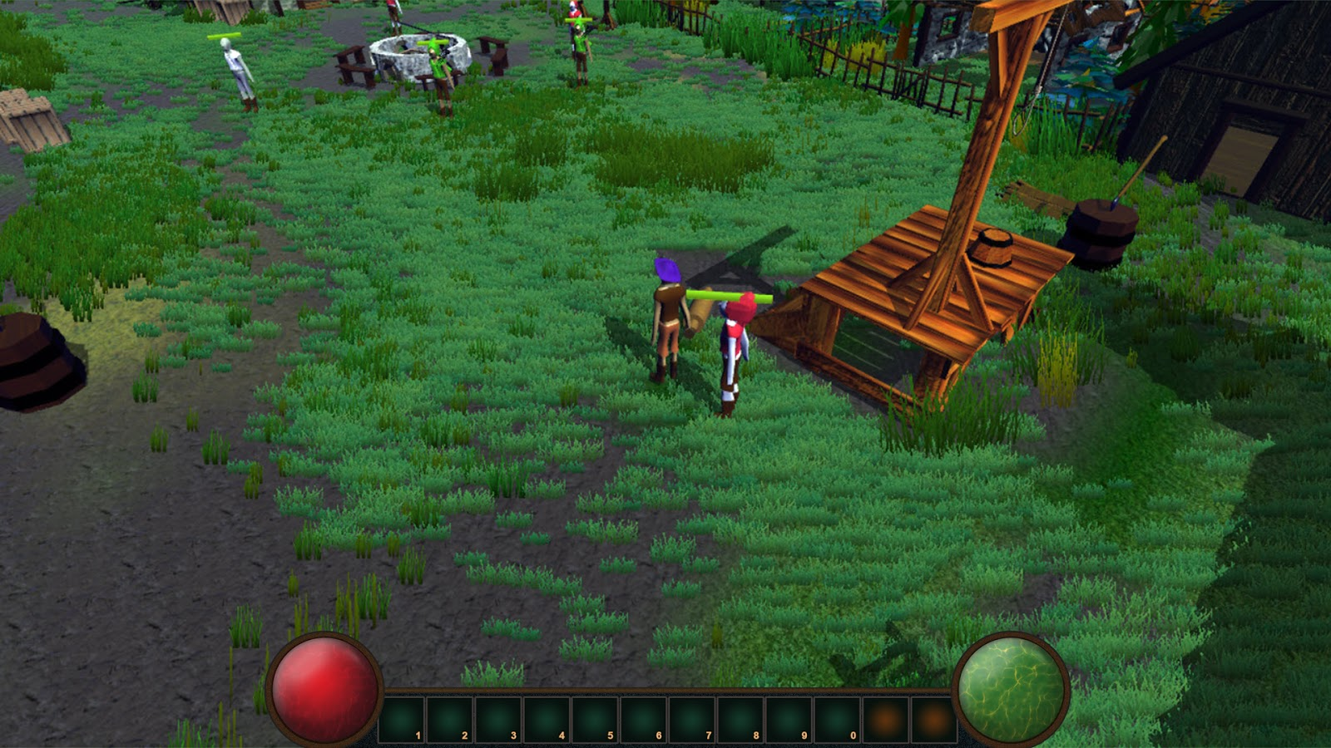

**Camera:**

The game is played with a fixed-camera isometric view (note: using the loose definition of isometric meaning 3/4-ish top-down view). The player character will be locked to the centre of the screen.

**Character:**

The player controls their “hero”. Our twist on the unlikely hero is to have the character be an old man, strong from years toiling in the field, but green to adventuring and naive to the dangers of the world. He will be crotchety and cantankerous in a funny, semi-offensive-to-others kind of way. He has strong opinions on politics and how the country is run and finds himself in a situation where those around him suddently expect him to take action.

The player will shape the direction that their character evolves in terms of strength, intelligence and other attributes, selected when leveling up. Through dialogue choices (eg. friendly, honorable, nasty, sarcastic, etc) the player will shape how they see their Hero’s personality.

Character selection / customisation (ie. the look of the character) has been set as a design stretch goal.

The character will have the following general gameplay actions:

* Stand still and do nothin’
* Move (one speed, kind of a fast version of an old man’s shuffle)
* Attack enemy (either melee and ranged depending upon weapon equipped)
* Interact with world object
* Interact / speak with NPC
* Use special attack
* Use inventory item (eg. healing potion)

In addition, the player will also be able to:

* Manage inventory
* Manage stats / abilities / level ups
* View and manage quests (stretch goal)
* Save, load and other game functions
* Select dialogue options when engaged in dialogue
* Interact with world map to travel to new locations (we may or may not have world map - its a stretch goal)

**Controls:**

The game will be created as both mouse + keyboard as well as controller supported. Ideally, we will allow customisable key mapping (design stretch goal).

As a starting point we will follow standard conventions for RPG controls (specifically, Diablo 3 controls) - that is, mouse to move / attack as well as click on the HUD icons and keyboard to access hotkeys for all HUD items, menus, special attacks, etc.

Reference: Diablo 3 controller configuration

**30 Seconds Of Gameplay**

**Context / Setup:**

You have been given a quest! “Resistence is Feudal”. You learn from a fellow peasant (Derk Diggler the Potato Farmer) that the Queens’s men have forceably taken control of a nearby town, forcing the villagers to give up their food and houses to the soldiers. The peasants are enraged but lack the courage to take action. Derk suggests that you ask the soldiers to kindly leave. You think they need a swift kick in the pants.

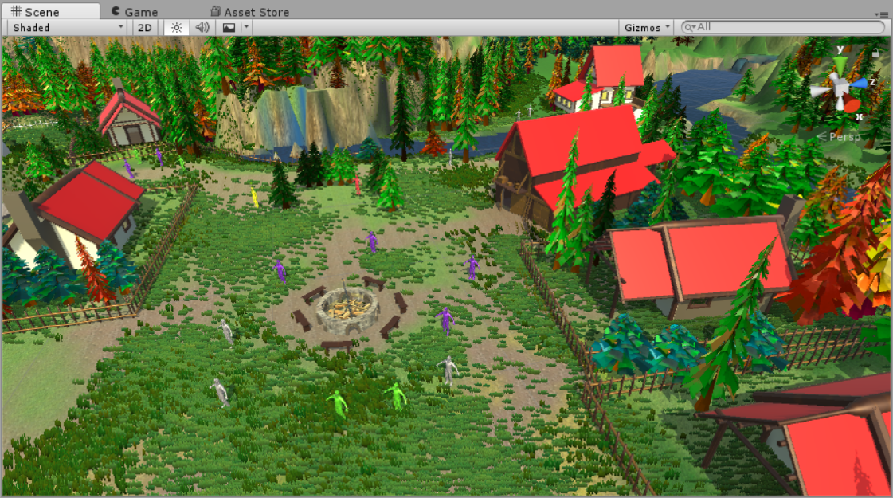

**Player Actions:**

* You click on the character named Derk. A text box appears and voice over commences. Derk explains the situation (soldier in town, need help). You are given 2 options for your reply:
  + “Its time to remove the filth from this town!”
  + “You know, I could use a nap, maybe I’ll come back later”
* Of course, you select the first response. Derk replies with a cheer.
* A popup on screen notifies you that you’ve started a new quest “Resistence is Feudal”.
* You now have control of your character. The camera is fixed, 3rd-person. You move your mouse to the right of the screen. Your character, staying centred in the camera, moves to where you clicked. As you reach where you clicked, a huge, fat NPC with a bald purple head and soldier’s uniform rushes out from a hut and blocks your path. He is swinging an oversized Ball-and-Chain above his head.
* A dialogue box appears. He says, “Stop right there or feel the wrath of William Heli”.
* You have three options of what to say:
  + “Move aside good sire, I mean you no harm”
  + “Shut your pie hole and git that big fat melon of yours out of my way.”
  + “I am here to cleanse this foul land of the taint of Beelzebub!”
* Being an honourable hero you selection option 1 by clicking on it.
* The dialogue box shows the text “Charisma Check…. Failed, oh no!”  
  (You start to think that you shouldn’t have put all your points into strength!).
* William Heli replies “I’m going to smash off your ‘ead and feed it to the chickens and then gather the eggs they make and scramble them and cook them lightly then eat the eggs which means, indirectly of course, I’ll be eating your head for breakfast tomorrow!…”
* The dialogue box slides off screen. You hear audio of a woman screaming off screen and upbeat fighting music (gladiator style) begins. Combat has begun.
* You click on William Helo to start swinging your sword at him.
* You hit for 28 damage (you see the numbers float above his head).
* He hits you for 67 damage. Your hit point meter has been halved.
* You click the icon on the bottom of the screen for the one special attack you’ve learned so far: “Stabby Stabby”. Your “Fatigue” bar increases from 0 to half way full.
* Your character leans back, pauses for brief, interruptible second, then wildly pokes his weapon at William’s throat twelve times in quick, blurred succession. You hit for 103 damage. William is now at 30% health.
* You see the Stabby Stabby cooldown start, it will be another 12 seconds before you can use it.
* William steps backwards, you see his Ball-and-Chain sparkle and you click to the left of your character to move him out of the way of the big attack that William sends at you.
* At this point, 2 scrawny, ugly dogs wearing thick collars in the Queen’s colours come charging at you from off screen. They get to you quickly and bite you for 20 points and 18 points. You are nearly dead.
* You click on the health potion icon on the bottom of the screen and see +50 appear above your character’s head as you heal.
* You click on one of the dogs. Your character swings and hits for 35 damage.
* The dog yelps, turns and runs back the way it came.
* Unfortunately, William has taken another huge swing and this time hits you for critical damage (you see the word “crit” appear next to the damage amount). You take 87 points and fall to the ground.
* Your character looks directly at the camera, points his finger at you, shakes his fist, then collapses in a crumpled heap.
* You have died. The words “Your Life Is A Joke” fill the screen, then the screen fades to black.
* The screen fades back up from black a moment later. Your character looks up at the camera again, shakes his head and the returns back to his normal pose. You see that you are once again in the small town and due to the marvels of auto-saving you are free to enter the town again or turn-tail and run away from whence you came.

**Gameplay Features**

We will prioritse a consecutive Vertical Slice approach, with some horizontal slice flavour to help the game flow. That is, we will start with combat and drill deep into the mechanics of combat before then moving on to the next major chunk of development.

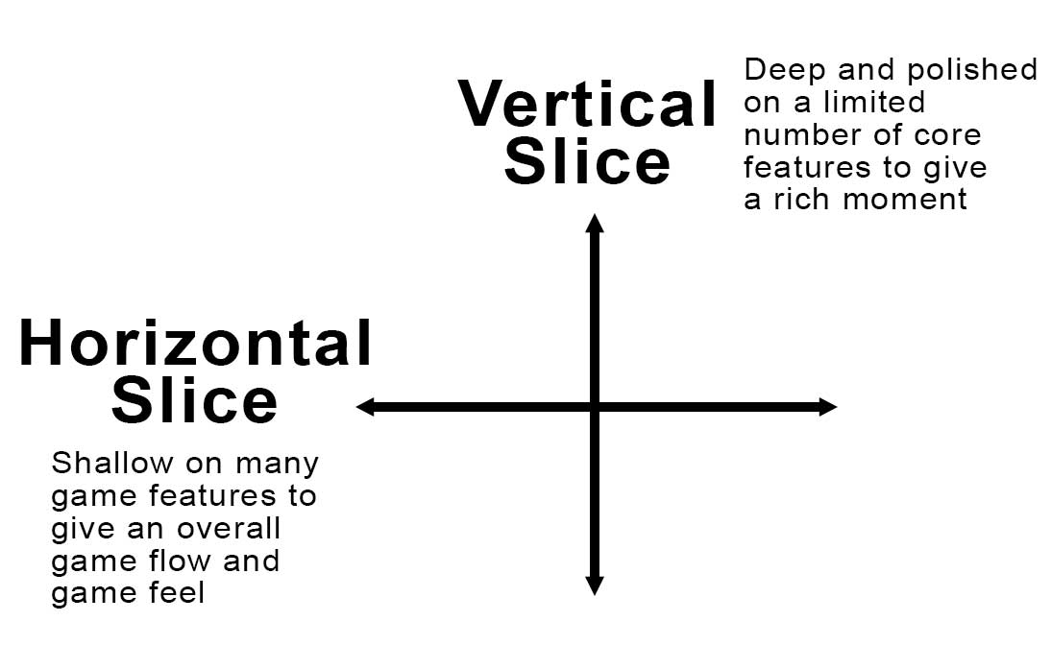

**Most likely our feature implementation priorities will go like this:**

* For the first major milestone (combat):
  + Player movement
  + Basic combat with melee and ranged attacks
  + Basic enemies with melee and ranged attacks
  + Simple prototype level with enemies placed as specific points in the level
  + Special abilities and special attacks for player and enemies
  + Player attributes which effect modifiers
* For the second major milestone (progression and game flow):
  + Player progression, XP, leveling up
  + Creation of level editor (or equivalent system) - place world pieces, enemy spawn points, doors, etc
  + Simple dialogue system
  + Saving, loading, level progression
  + World progression, perhaps with meta-map and fast-travel
  + Fully implemented inventory system
  + Items impact modifiers / stats
  + Loot drops linked to enemies
  + Lots of UI optimisations and icons for inventory
* For the third major milestone (story, dialogue, quests, tuning):
  + Fully implemented dialogue system
  + Quest system
  + Non-interactive moments editor (ability to lock the player and control the camera and NPC / monster behaviour).
  + Implementing content, tuning and balancing the game, adding any last stretch features that we want to sneak in there
  + Art and audio polish
  + More enemies, boss battles, NPCs, levels

**Combat and Movement**

The following is the most ugly diagram I could come up with. I even used pink text. I’ll try to best this performance, but it might be tough.

Oh yeah, and it explains the core of the gameplay and movement.

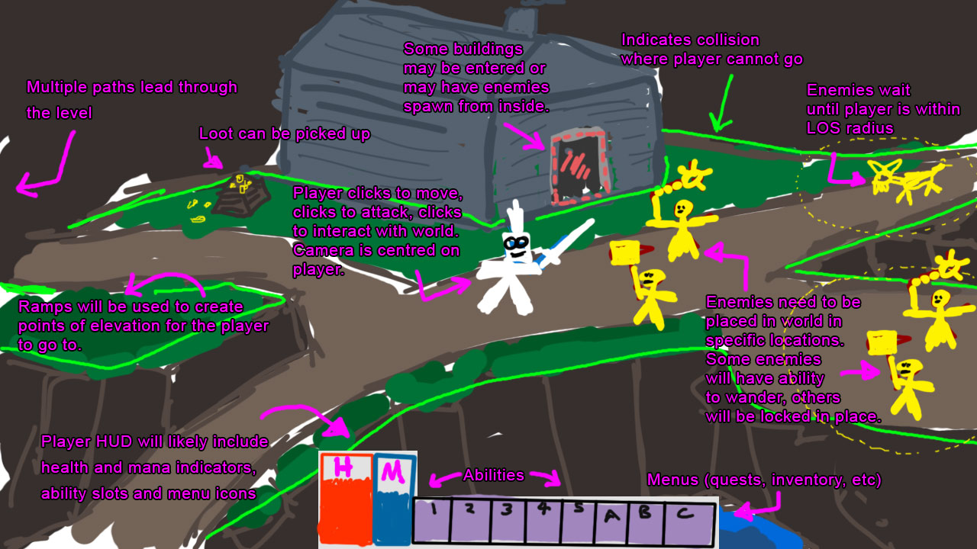

Here are the things the player can do (listed with mouse/keyboard, these will also be mapped to controller):

* Left Click on a place on the ground to move to that location.
  + Requires collision
  + Requires pathfinding
* Left Click to interact with world objects:
  + Doors, NPCs, loot.
* Left Click to do regular attack on enemy
  + Requires a check to see if object is enemy
  + Will move character directly to that enemy
* Right Click to do big attack on enemy
  + Same as regular attack but has slower animation and more damage.
  + Uses small amount of mana / energy / juice
* Use ability (either by using hotkey or clicking on icon in HUD)
  + Immediately triggers that ability.
  + Damages / interacts with enemies as per the ability design.
  + Reduces mana / energy / juice
* Use consumable item (once used it is consumed)
  + Use item to increase health
  + Use item to increase mana / energy / juice
  + Use a scroll or something similar to buff themselves or attack enemies

Here are the core things an enemy can do:

* Stand still, waiting for the player to enter their LOD radius (ie. when they can “see” the player)
* Rush at the player
* Attack player with regular attack
* Attack player with special attack

Other things an enemy can do (not as high priority, but nice to have)

* Wander around a certain defined area (could be based on radius of start point)
* Patrol in a specifically defined area / on a path (needs to be more specific, like down a particular road)
* Adopt an “alert” pose where they can see the player but dont yet rush at him.
* Run away from the player
* Taunt the player (ie. not moving or attacking but triggering some sort of animation and sound effect)
* Transition from friendly to enemy state based upon dialogue options or current game state (eg. town is on high alert and characters attack player on sight).

**Hitting and Being Hit**

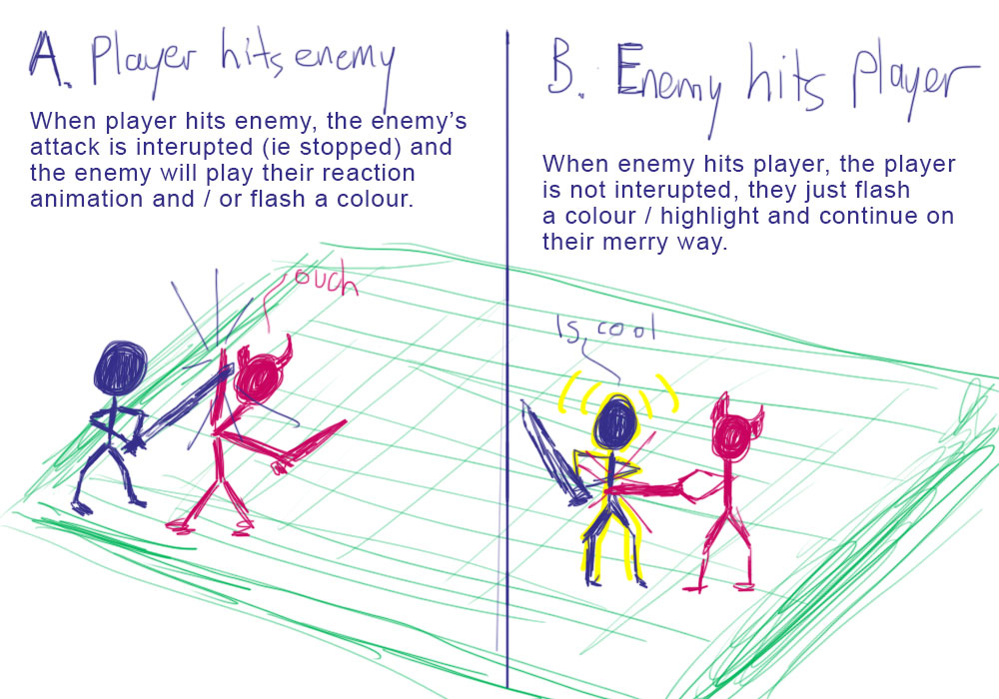

**Special Abilities and Attacks**

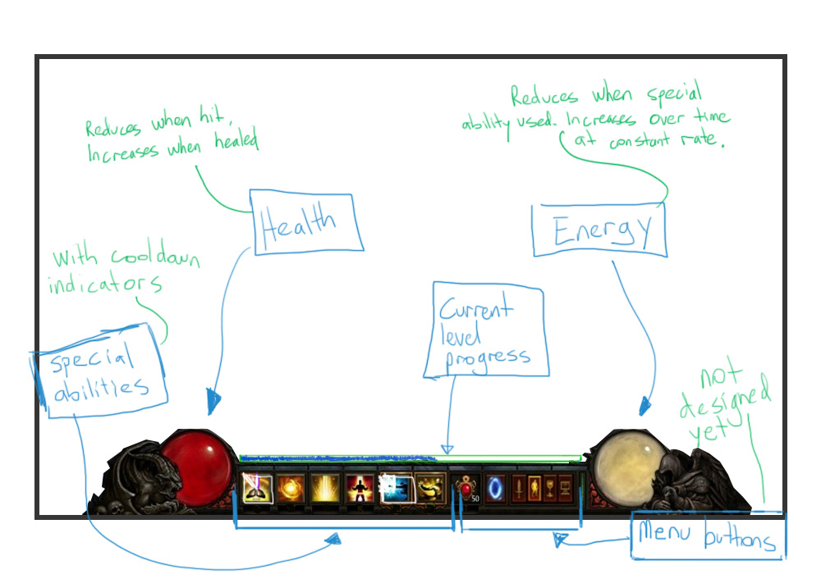

For the first iteration of the prototype we should focus on a core mechanic that allows for lots of expansion but isn’t complicated from the get-go. Here is the proposal:

* Left click (or A button) is for regular attack.
* Right click (or B button) is for power attack and uses “energy” (note, this could be themed as energy, mana, mojo, fatigue, etc). The power attack has a slower animation and does more damage.

Steps we can implement to slowly advance the power attack into full blown abilities:

1. Power attack, uses energy (special attacks would use energy)
2. Add a cooldown to the power attack (special attacks would have cooldown)
3. Add the ability to use a hotkey to execute a second type of “power attack” (or ability) which has a different effect on an enemy such as stun. It costs energy in the same way the first power attack does.
4. Once we have a few “abilities” (ie. more advanced power attacks that have interesting impacts on enemies) we can remove the energy cost to do a power attack (it just becomes a second interesting choice for free attack with a long wind-up and big damage payoff) and we put the abilities that a player has on their hotkeys from 1 to 6 (or so) on the keyboard or mapped to specific buttons on controller.

The following is a list of general special ability types that we should consider implementing (note: just a brainstorming list for now - feel free to add to):

**Melee Hitting for Damage**

* Power hit - player charges up and does a large hit with more damage (either a fixed amount or a multiplier to current regular attack damage)
* Ground pound - causes damage to all enemies in a particular radius around the character or around where the character’s attack lands.
* Knock back - smashes an enemy backwards
* Dash and Slash - player quickly moves from one place to the next, damaging enemies he passes through
* Eye poke - Three stooges style, player aims for enemies eyes and if successful will render enemy unable to attack for X seconds
* Cleave - huge swing, player has X% chance of instantly killing enemies under a certain level.
* Flurry - player strikes out with 5 quick hits in fast succession
* Whirlwind - player spins around, damaging any enemies that he connects with, each time he connects with them
* Berserk - player loses X health but gains X% extra damage
* Focus - player gains a bonus to critical hit chance
* Shield Bonk - if the player is holding a shield they can use it to bonk an enemy on the head, stunning and dealing big damage
* 6-inch punch - crotch shot. Stuns opponent for X seconds.

**Ranged Hitting for Damage**

* Power shot - for ranged attacks, player charges up their weapon and hits for additional damage
* Explosive shot - upon hitting, explodes and causes AOE damage
* Big Bertha - player shoots a gigantic projectile that does uber damage
* Holy Hand grenade - Player lobs a grenade that explodes and causes much carnage
* Quick shot - shoot X number of arrows in quick succession
* Hail Mary - player shoots arrow straight up in the air, it sails off screen and a large bird falls out of the sky and lands on the enemy
* Double arrows - for short duration the player will shoot 2 arrows each shot they make
* Fan of blades - arrows / knives shoot out from the player in all directions
* Mud flinger - player hurls mud at enemy’s face, stunning and blinding them for duration
* Ice Arrow - player shoots a bolt of ice which freezes the enemy
* Fire Arrow - player shoots a fire arrow which sets enemy on fire and does additional damage

**Spells Cast**

* Stun / freeze - stops enemies where they are hit, they cannot move and cannot attack for X seconds.
* Poison - does initial damage and then X damage per second
* Fear - makes enemies run away or run around distracted
* Rage - makes enemies attack other enemies
* Polymorph - turns enemies into things like rabbits
* Lightening chains - damage bounces from one enemy to the next
* Fireball - player casts a projectile fireball at a particular enemy
* Blizzard - player causes a storm of Orcs and Trolls to fall upon his enemies (what do you reckon Mikey?) :-)
* Raise dead - player can turn corpses into short-lived skeletons that will attack enemies
* Heal - player heals themselves for certain amount of health
* Shield of Impenetrability - a shield (orb) encompasses the player making them invulnerable for short amount of time
* Scary shout - player shouts some nasty words at enemies which makes them scared and run away

**Combat Modifiers and Damage Dealt**

The following shows the modifiers and bonuses that will be factored into the amount of damage dealt by the player for each standard attack.

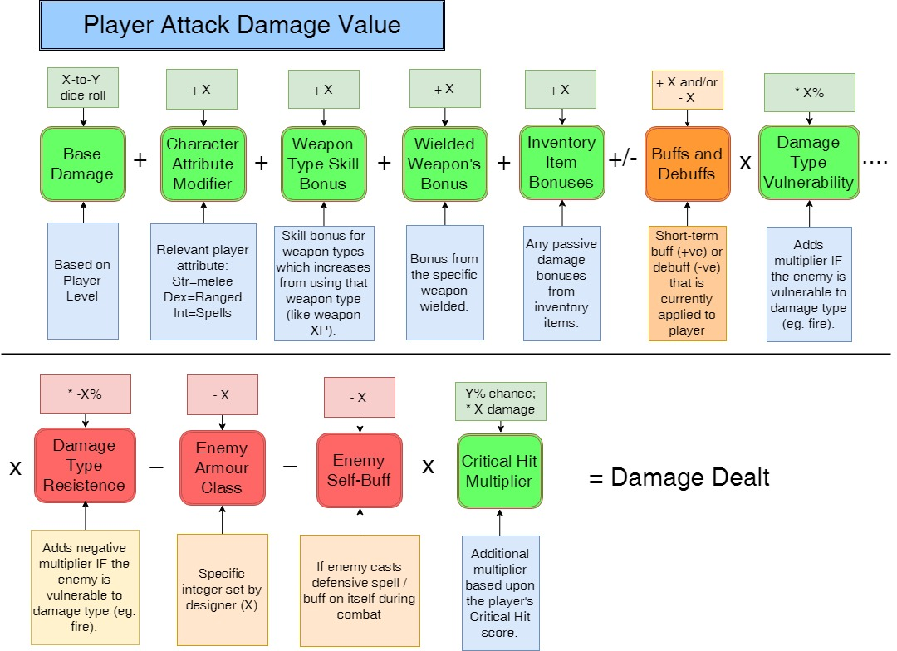

A similar calculation is made for when the enemy attacks the player. The elements are simplified with things like base attack, attribute bonus, weapon bonus, inventory bonuses all rolled into one number (Base Attack).

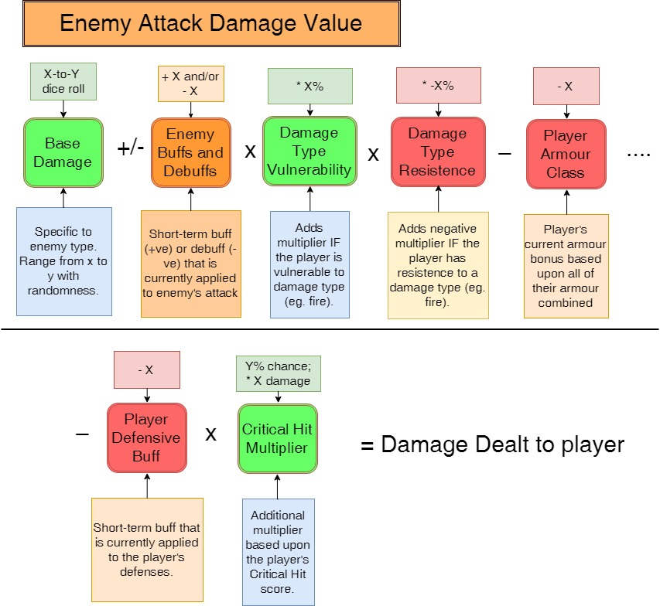

**Weapon Types**

Here is a list of weapon types / categories we plan to have in the game:

* Dagger (1h)
* Sword (1h)
* Sword (2h)
* Club (1h)
* Staff (2h)
* Axe (1h)
* Axe (2h)
* Hoe (1h)
* Hoe (2h)
* Sickle (1h)
* Sythe (2h)
* Mace (1h)
* Crossbow (R)
* Bow (R)
* Throwing Axe (R)

**Character Traits and Progression**

Player ability stats will follow a fairly standard D&D / RPG approach. Names have been tweaked a bit to be slightly more absurd / funny / interesting. Player feedback needed to see if they like this or if they want to tried and true str, con, int, etc.

|  |  |  |
| --- | --- | --- |
| Trait | Modifies | Pre-Requisite For |
| Strongness | (Strength). Modifies damage dealt from standard attacks. | Wearing heavy armor |
| Fastness | (Dexterity). Modifies how likely player is to be hit by attacks. | Wielding ranged weapons |
| Toughness | (Constitution). Modifies total HPs |  |
| Smartness | (Intelligence). Modifies magic ability | Learning spells |
| Charmingness | (Charisma). Modifies negotiation and prices | Learning certain bard-style abilities |

* At the start of the game the player will start with minimum stats in each and be given some initial points to spend as they see fit, thereby shaping the type of character they play. Knights require Str, Archers require Dex, Wizards require Int, Bards require Cha.
* Certain things in the game will have pre-requisites based on these traits. Things such as:
  + Weapons
  + Armour
  + Spells
  + Special Attacks
* As the player completes actions in the game they accrue Experience Points (XP). Once a threshold of XP is reached, the player will be able to level up their character by placing a new point into one of their traits. The full design of how many XP points the player receives will need to be designed, spreadsheet style, with the following things providing XP:
  + Killing an enemy
  + Subduing an enemy (if we have such a thing)
  + Completing a quest

**Linking Character Trait Scores with Dialogue**

FEATURE REQUEST: Within our dialogue system it would be good to have the ability to pull from a player’s stats to feed a string within a sentence. For example:

NPC: “I can see by looking at you that you are a [Current_Intellignce_Score] fellow”

Would become

NPC: “I can see by looking at you that you are a fairly dim-witted fellow”

Here is an example of how we would anchor the stats:

|  |  |  |
| --- | --- | --- |
| Trait | Score |  |
| Str | 3 | Crippled |
| Str | 4 | Puny |
| Str | 5 | Delicate |
| Str | 6 | A Weakling |
| Str | 7 | Feeble |
| Str | 8 | A Marshmallow |
| Str | 9 | Soft |
| Str | 10 | Out of shape |
| Str | 11 | So-so |
| Str | 12 | Fit |
| Str | 13 | Muscley |
| Str | 14 | Buffed |
| Str | 15 | Ripped |
| Str | 16 | Huge |
| Str | 17 | A Gorilla |
| Str | 18 | An Ox |
| Str | 19 | A Monster |
| Str | 20 | Gigantic |
| Str | 21 | God-like |
| Str | 22 | An Incredible Hulk |

**Branching Dialogue System**

Branching Dialogue - We will need a pretty hefty editing system to allow us to attach specific dialogue to specific NPCs, quests, game events, etc.

Note: investigate “Fungus” on Unity Asset Store. Its a free tool which may assist with branching dialogue.  https://www.assetstore.unity3d.com/en/#!/content/34184

**World and Level Creation**

We will need a decent level editor to allow for quick creation of content. Needs to include placement of modular terrain, placement of non-interactable props, placement of interactable objects, NPCs, doors, portals, enemies.

**Inventory and Loot**

To be designed later when we have a feel for combat. Lots of UI design work and 2D art will be needed for this.

**Story and Theme**

Reference images for flavour only

**Our Hero**

Rick’s proposal is that we base our main character on Cohen The Barbarian from the Discworld series for his attitude, elderliness and his ability to be a badass but decrepit at the same time. Here are some references:

<https://www.youtube.com/watch?v=Rwys24noBxs>

<https://www.youtube.com/watch?v=R67KXSxMJq8>

<https://youtu.be/nMNOWPHTp6c?t=150>  (up until 5:32 in the clip)

* The planned theme for this game is “Failure does not tolerate persistence”. Our character is stubborn and headstrong despite his failings.
* Our character needs to be funny and absurd in his own way. Here is the current idea:
  + As players we are not entirely sure if the character is or isn’t a hero.
  + At the start of the game we lead the players to believe that the character is a fairly humble cabbage farmer. Then we show the character being cracked on the head (possibly by his hoe - the classic, step on the end of the rake schtick).
  + The character loses his memory but believes that he is a great fighter and resistance leader for the people’s freedom movement. His life-long quest is to free the repressed peasant folk from the shackles of oppression. As players, we think that our character believes this because shortly before his accident, he had met such a character.
  + As the game progresses, the character actually does grow in this hero. He becomes the legend he thought he was. And as a final surprise twist (spoilers ahead…) we learn at the end that he actually was the great hero all along.
* So, at the start of the game, the character is:
  + An 86 years old who has little skill in combat or adventuring, but some natural talents that tend to “come back to him” after doing those things and practicing.
  + The “hero” will be inherently flawed but also wirey and strong from what we believe to be his years in the field. But he also has a bad back, arthritis and is generally falling apart.
  + He is naive in the ways of the world as only an old person with amnesia can be.
* The character is stubborn, opinionated and resolute in his ideals, his views on politics and his dislike of loud music that those kids are listening to nowadays. He also love soup.
* The person playing this game (ie. the player) will be seen as “God” by the character with plenty of “breaking the 4th wall” going on where the Hero looks directly at the camera and addresses the player. The hero will communicate his emotions to the player directly - fear, excitement, frustration, etc, often referring to the player as “my Lord” in a condescending way. In this way we will create a two-way buddy-bond between player and character.
* The hero might be unskilled, but he refuses to give up. He is stubborn and headstrong. His belief in “the cause” is strong (the cause being an anti-authoritarian, peasants-against-nobility type thing). He just assumes that his skills are a little rusty.

**Our Villain**

* While the peasants are the heroes, the nobility are the enemy. The royal family is most hated. The knights and Queen’s men are despised. There is a constant overtone of oppression, arrogance, superiority, and so on.
* The Queen is dying. Normally this would bring rejoice from the peasants, but his eldest and only son, Prince Derry, heir to the throne is a stupid, cruel man that everyone hates. Reference for Prince Derry is Prince Edward from Braveheart.

**Our Struggle and Objective**

* Our hero seeks to stop the oppression and inequality. He didn’t want to be a leader, but gradually finds himself speaking for the 99%. He is not sure how he is going to do it, but it is time to start a revolution, free the people and bring down the monarchy once and for all.
* The Queen’s soldiers, nobility, landed gentry, knights, and others in power want to stop our hero so that they can retain the status quo that keeps them fat and happy.
* Our hero will find underground-resistence style support from other peasants wherever he goes. Simple folks who are willing to provide provisions and to buy and sell the contraband goods that our hero find and needs in his adventures.

**Our Call To Action And Motivation**

* The character has a brief encounter with a representative from M.O.I.P (the Minister Of Intriguing Peasants, or Ministery Of Interesting Peasants, or Ministery of Invinsible Peasants, or other variations, depending upon who you speak to - the goal is to be a little confusing). His mind is filled with the grand vision right before receiving his blow to the head. The representative mentions the great peasant leader, [Name to be decided, lets call him Albert for now]. If we can pull it off, this message should be delivered in a way which is ambiguous enough that the player might believe that the character is actually Albert, or that they are not Albert. Perhaps Albert is a metaphor? Or a codeword for action? Ideally, some players will believe they are Albert, some will not.
* The player is draw heavily by his quest to free the people. He is also drawn heavily by his quest to figure out who the heck he is.
* Throughout the game we will leave clues and hints to the character’s true identity in many absurd ways. We should make a habit of having characters die who are just about to reveal a critical clue to the player.

**The Peasants**

* Our hero is a champion for the peasants. We want the peasants to be downtrodden and dirty, but a stark intellectual contrast to the solidiers and nobility. The peasants are knowledgeable and eloquent whereas their “betters” are simple oafs or arrogant fools or bumbling twits.

**Story Flow For Prototype Village Level**

**Level Overview:**

* Player is guided through the level by HORATIO PICKLES, an innocent looking gentleman with a proper manner of speaking. HORATIO turns out to be the villain - zoing! He guides the player to take possession of some kind of holy relic (the Holy Mackerel?), only to reveal himself as an evil wizard and to steal the relic for himself. The classic “I couldn’t go in there and get the thing but you could” trick. He taunts the player about this.
* The main encounters are with Queen’s soldiers. Boss battle with an Knight - Sir Gregor-ee! (pronounced with a high pitch “eeee”)
* The villagers provide support and flavour throughout the level and are generally eloquent and intelligent.

**Main Level Beats:**

1. Initial fight with a thug - establish that he has a family and that times are grim.
2. Interact with HORATIO PICKLES - weird time travel thing where he keeps appearing down the road.
3. Fighting with soliders on outskirt of town.
4. Meet Daisy (the thug’s wife) looking for her husband who you have recently killed.
5. Main village battle with lots of soliders in the centre of the village.
6. Re-connect with HORATIO who mentions the holy relic and gives a clue to seek an old hermit.
7. Find and meet old hermit. Prefers to think of himself as an eccentric recluse. Gives another clue to go to the swamp. Guarded by the vicious and evil… “swamp donkey”
8. At the swamp, have to battle the dreaded Swamp Donkey.
9. At the castle, battle Sir Gregor-ee.
10. Final confrontation with HORATIO.

**Story and Dialogue Flow:**

1. Player is met immediately by a no-name thug (Barry the no-name thug) and set upon.   
   [BARRY THE NO NAME THUG]: (gruff voice) “Okay, you ugly old prune, hand over your money, I’ve got a family to feed”   
   [BARRY THE NO NAME THUG]: (on dying) “Tell my wife, Daisy… I love her… Oh and my young son, Barry Junior, I love him… and my cousins Jimmy and Bobby… uugghhh, so much… to… live… for...ugghhh”
2. After short distance player meets a regular looking villager / shopkeeper.  
   [HORATIO PICKLES]: (terribly british voice): “Well met friend, I say, you’re on the right path to the village”.
3. After short distance player see the same villager / shopkeeper.  
   [HORATIO PICKLES]: (regular voice): “I can assure you that the village is still open for business. Onward and upward!”
4. After short distance player see the same villager / shopkeeper.  
   [HORATIO PICKLES]: (regular voice): “No reason at all for you to turn around and go elsewhere. Nope, none whatsoever.”
5. After short distance player see the same villager / shopkeeper.  
   [HORATIO PICKLES]: (regular voice): “Jolly fine day for a stroll... with no cause for alarm at all. Tally ho!”.
6. Player rounds a corner and sees a group of guards.  
   [SERGEANT PIKE]: (arrogant) “Well, well, block your noses lads, something stinky just turned up.”  
   <Combat with soldiers>
7. Player sees the villager / shopkeeper again. Preferably in a place where the player can see the church down the hill.  
   [HORATIO PICKLES]: (regular voice): “Nice work old chap. Come look for me at the church when you arrive in the village.”
8. Player passes a small boy on the road.  
   [NURPLE THE SMALL BOY]: (In child’s voice): “My name is nurple. You look ugly.”
9. Archers are practicing Archer.  
   [AARON THE ARROGANT ARCHER]: (Creepy, excited): “Nice! A moving target!”
10. At a small farmhouse the player meets a distressed lady.  
    [DAISY] (upset): “Please sir, help find my husband. He went to find food and hasn’t returned. He’s wearing a stupid yellow vest.”
11. Player is ambushed by some more wandering soldiers. Their engagement dialogue gives general clues to the state of affairs:  
    “Stupid peasants don’t know when to quit”  
    “Okay boys, lets have a bit of fun with this one”  
    “You’re never too old for a beating grandpa”
12. During one of the fights one of the soldiers runs off to get reinforcements  
    [CAPTAIN SPOONER] (Making a command): Jenkins, inform Sir Gregor that we have trouble”  
    [LEROY JENKINS] (running off, calls out over should): LEEEEROOOYY JEEENKIIINNNSSS….
13. After a battle in the main town square HORATIO PICKLES once again appears at the church.   
    [HORATIO PICKLES] (concern in his voice): “Sir Gregor-ee [the “eeee” is high pitched and lengthed… like the “knights who say “nee”] will be here soon. To defeat him you’ll need to find the Holy Mackeral, the most ancient and deadliest relic known to man. Go back through the village, cross the bridge and follow the river north to seek Herman the Hermit”
14. Player passes random NPCs en route. Use random dialogue.
15. Player arrives at a small hut. Find a man standing outside.   
    [HAROLD THE HERMIT]: (old voice, simple, working class) “No, I’m not Herman the Hermit, I’m Harold the Hermit. This is 36B... you want 36D... its the big shack round the corner”
16. Player has battle with non soldier enemies (some sort of wild creatures).
17. Player finds Hermin’s shack.  
    [HERMAN THE HERMIT]: (more educated sounding) “I prefer to be called Herman the Eccentric Recluse, thank you very much. The last I heard, the Holy Mackeral was last in the Salty Swamp, south of the village. Be warned, the swamp is home to a the fierce and aggressive... Swamp Donkey!
18. Player runs through town, more NPC encounters
19. Player meets HORATIO at the bridge to the castle (where the player can either go to the castle or to the swamp.  
    [HORATIO PICKLES]: (more rushed): You’re so close! I can smell it! Once you have the Holy Mackeral from the swamp, you’ll find Sir Gregor-ee at the old castle. Tally ho!
20. Fight with Swamp Donkey at the Swamp.  
    [SWAMP DONKEY] (hideous sounding woman’s voice): “Freeessshhh Meeeaaattt!”
21. After killing Swamp Donkey  
    [SWAMP DONKEY] (death): “We are all dooooommeeddd…!”
22. Player heads to the ruined castle and meets Sir Gregor-ee  
    [Sir Gregor-ee] (pompous): “Guards! Remove this disgusting peasant... Guards? Fine, I shall do it myself”
23. After defeating Sir Gregor-ee the player runs towards the Cave of No Return and again meets HORATIO, but he has changed appearance to look more like a dark wizard.  
    [HORATIO PICKLES]: (a more condescending tone to his voice): “Mwahaha! My minion has arrived! You are a dim-witted, doddering old sausage, bringing the ultimate weapon of evil to the most powerful wizard in the realm… Mwahaha! Your world is doomed!
24. It would be awesome if we can fade to black!

**NPC filler dialogue:**

* Ralphy the small boy (Ralph Wiggins in tone):
  + You smell bad
  + I like potatoes
  + I saw a bird
  + I ‘et a worm
* Gretchen the village crone (indignant, pissed off):
  + We are all repressed
  + Monarchy? Pfftt, more like dictatorship
  + *Short* live the queen, I say
  + Oh I don’t like that Sir Gregor-ee (the “eeeee” is high pitch and lengthened)
* Seamus the shopkeeper (working class, neutral tone)
  + Something fishy with the fish this year
  + Alrigh’ old fella?
  + I’m sick of them soldiers
  + You selling or buying, if you know what I mean...
* Puddy the Potato Farmer (working class, neutral tone)
  + Bad crops this year
  + I do like good soil
  + Thats a nice hoe you’ve got there
  + Farming is honest toil, I say
* Dougal the peasant (northern “hard to understand” accent)
  + Oh aye, I’ll take two I will
  + That’ll be that is what
  + A bird in the hand as they say

**Enemy Design**

Where possible, with enemy design we should implement functionality before deciding on the theme / art assets of the enemy:

1. Start by prototyping the behaviour we’d like to see the enemy doing. Use placeholder art.
2. Tune and tweak the available variables for the enemy.
3. Decide on the theme and art of the enemy.
4. Clone the enemy with variations so that we squeeze as much variety out of the functionality and assets as we can. For example, change the enemy’s weapon from a sword to an axe, double its HPs, increase its hit damage and its Axe-Man, the tougher version of Sword-Guy.

Here is where we can document some enemies we’d like to see in the game. We can use this as ammunition for our community to vote and / or create these characters:

**Angry Peasant**

* This could be a generic class with some easy copy-paste cloning to make slightly different variations.
* Looks shabby.
* Carries pitchfork or similar weapon. Would be good to have a few similar, interchangeable weapons. Would be even better to make these weapons funny (holding it the wrong way or swinging it in an odd manner)
* Attacks with a long thrust of his weapon.
* Slow moving.
* Design behaviour to prototype:
  + Move to player and attack with weapon
  + Random chance that it attempts to flee once health reaches certain amount

**Enemy Knight**

* Formidable foes wearing armour and holding a shield.
* Can have different looking weapons to give impression of variety - sword, mace, war hammer, etc.
* Design behaviour to prototype:
  + Standard “stand and deliver” attack
  + Special attack that has a “tell” and does more damage (big swing)
  + Special attack that stuns the player. Shield bash perhaps.

**Deadly Rabbit**

* Looks like a fluffy white bunny.
* When attacks, has huge blood stained fangs.
* Difficult to click on and hit - bounces around a lot
* Design behaviour to prototype
  + Quick leaps to attack the player then to jump back out of range
  + Random hops to and fro (not necessarily attacking, just bouncing around)
  + Leaping from the ground up to the player’s face for an attack

**Armless Black Knight**

* Dressed as a Knight with black armour.
* Has no arms.
* Attacks by headbutting.
* Design behaviour to prototype:
  + Doesn’t run, doesn’t move around, just approaches the player and headbutts.

** Add enemy design ideas as we have them.

Comment:

What about damageable civilians that run away when hostilities start, but will turn on the PC in a mob if any are killed? Maybe they are super irritating like Dennis from the holy grail. Good opportunity for community contributions.

**[Brainstorm] Silly Ideas / Funny Stuff**

* Bugle of Irrationality
* Fallacy of Sunk Costs
* Emperor's New Clothes
* William Helicopter
* Occam's Razor
* Watch [Sam's Mum](<https://youtu.be/JipYDDXo5C0?t=9m02s>)
* Listen to [Monty Python Sings Music](<https://open.spotify.com/album/7DYqf49PCZbUVgr10N3zMy>)
* Animals which are a satire of the mythological beasts. For example, head of a horse, body of a man (the reverse  centaur).
* Main villain - Prince Derry, heir to the throne. Or prince Derry-heir as he is known. Also known as the Royal Backside, his Royal Anus and Lord Bot Bot.
* MOIP - Ministry of Intriguing Peasants.
* Shove it in your arsenal

**NPC Character Ideas**

Here is where we document some characters we’d like to see in the game. We can use this as ammunition for our community to vote and / or create these characters:

**William Helicopter**

* Stereotypical Blacksmith. Broad shoulders, bit of a belly, very hairy.
* Wields a Ball-and-Chain style Mace.
* Lives in a village. Is very anti-establishment and wants to bring down The Man.
* Easily angered. Not easily charmed or intimidated.
* Could potentially be a shopkeeper / weaponsmith for purchasing weapons.

** Add NPC ideas here as we have them.

**Tools, Plugins, Asset Store Ideas**

* Localisation:  <https://www.assetstore.unity3d.com/en/#!/content/7543>
* Fungus: <https://www.assetstore.unity3d.com/en/#!/content/34184>
* Inventory Master:  <https://www.assetstore.unity3d.com/en/#!/content/26310>
* ORK Framework - RPG Engine:  <https://www.assetstore.unity3d.com/en/#!/content/14419>
* Skele Character Animation tools:  <https://www.assetstore.unity3d.com/en/#!/content/16899>
* Gameflow - Visual Scripting for Unity ($20):  <https://www.assetstore.unity3d.com/en/#!/content/14808>
* Nottorus - Visual Scripting for Unity ($250):  <https://www.assetstore.unity3d.com/en/#!/content/59656>
* UMA2 - Multipurpose Avatar:  <https://www.assetstore.unity3d.com/en/#!/content/35611>